**inSight 2017**

**Department : ECE department**

**Problem Title : Resume (online profile) builder and achievement tracker.**

**Problem Code : PS06**

**Problem Description :**

The students attend technical events like seminars, paper presentations, hackathons and many more. The faculties go to different colleges as guest lecturers, also to seminars and other events. In order to track these achievements of the faculty and students an application needs to be designed which would benefit the students and faculties by helping them build their resume(an online profile) and help the admin to keep track of the achievements. The application should provide students the interface to create their resume and store their inputs or responses in the form of a database so that it becomes a record for the department. This would enable the departments to track achievements of their students and faculties efficiently. This should also have provisions to edit their profile whenever they which to update their profile or resume. The application should be able to generate a report of these achievements whenever required.

**Proposed solution:**

*We will be developing an android application, which will have 3 log in options.*

*1. student log in or sign up option using USN and password.*

*Student profile includes basic information like name, USN, year of admission, DOB, address, semester etc. Student can fill his achievement like which place he secured or just participated and name of the event and institute where he participated and also can upload the certificate of the events.*

*2. Faculty log in or sign up option: using faculty id and password.*

*Faculty profile includes basic information like name, id, DOB, address, qualification, year of joining sit, previous work experience etc. Faculty can fill the information about participation in various seminars and guest lectures and can upload the certificates.*

*3. Admin log in: using fixed id and password.*

*Admin will be able to generate reports based on the achievements of students and faculties.*

*He will be able remove faulty accounts and also edit the profiles if necessary.*

**Technology Stack :**

* *Android: IDE used is Android Studio.*
* *Database to store log in information.*
* *Database to store resume.*

**Use Case:**

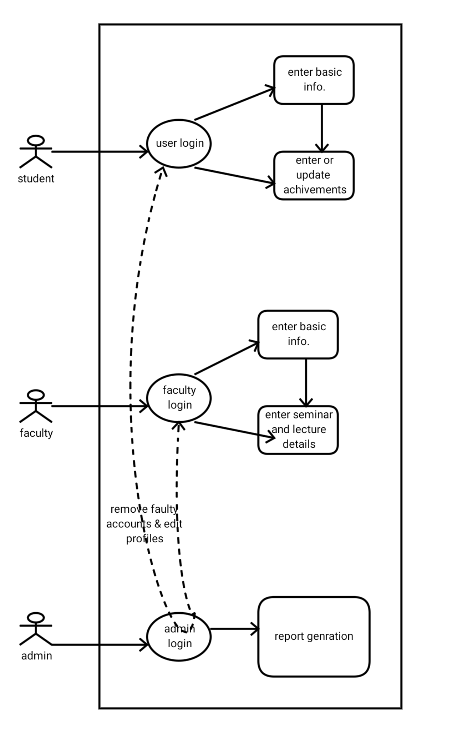

**Team Members details:**

|  |  |  |  |  |
| --- | --- | --- | --- | --- |
| **Role** | **Name** | **USN** | **Email id** | **Phone no.** |
| Team Leader | Pooja T R | 1si15cs075 | poojatbabu9@gmail.com | 7019958051 |
| Team Member 1 | Nidhi I Singh | 1si15cs066 | nidhiisingh02@gmail.com | 8884648310 |
| Team Member 2 | Hithyshi M | 1si15cs045 | hithyshim@gmail.com | 7847936100 |